# 

**TO SUPPLY LEFTOVER FOOD TO POOR**

SALESFORCE PROJECT DOCUMENT

SUBMITTED BY:

**NANDHAKUMAR.M**

BACHELOR OF TECHNOLOGY

IN

INFORMATION TECHNOLOGY

M.KUMARASAMY COLLEGE OF ENGINEERING

(Autonomous) KARUR - 639 113

JULY 2025

To Supply Leftover Food to Poor

**Project Overview:**

FoodConnect is an innovative Salesforce CRM-based solution designed to reduce food waste and fight hunger. Built on the Salesforce platform, it enables the collection of surplus food from sources such as restaurants, event venues, and households, ensuring timely and efficient delivery to NGOs and underserved communities.

The platform caters to multiple user roles including donors, NGOs, volunteers, and administrators providing customized features within a secure, centralized environment. Leveraging Salesforce’s custom objects, automation tools like Flows and Process Builder, and robust analytics through Reports and Dashboards, FoodConnect monitors every stage of the food donation process—from initial registration to final delivery.

With features like real-time tracking, role-specific data access, and seamless collaboration, the system optimizes food redistribution operations. Automated workflows, location-based volunteer assignments, and stringent data validation reduce manual effort and enhance overall efficiency.

By blending Salesforce’s flexibility with a mission-driven vision, FoodConnect delivers a modern, technology-powered approach to addressing food insecurity.

**Key Features:**

* Centralized platform for managing venues, donations, and volunteers
* Automated task assignments and volunteer coordination
* Location-based sharing rules for optimized delivery
* Detailed reports and dashboards for operational monitoring
* Role-based access control for secure user management\
* Future-ready design for AI and chatbot integration

**Business Need:**

Aims to reduce food waste and combat hunger through automation, precise tracking, and scalable coordination between food donors, NGOs, and volunteers.

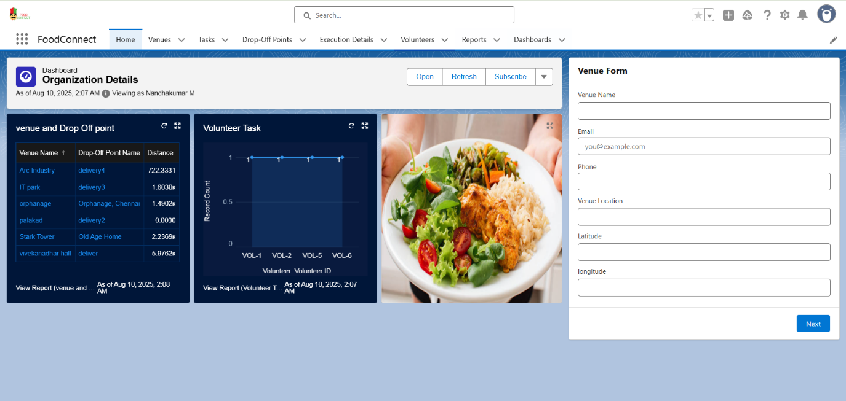

Fig 1 : Home Page

**Objectives:**

The primary objective of the FoodConnect CRM is to simplify and digitize the process of collecting and distributing surplus food. It brings together donors, NGOs, volunteers, and administrators on a unified Salesforce platform, enabling efficient tracking and delivery of food donations. By reducing manual tasks, the system enhances coordination and accelerates operations.

A major focus of the project is to automate key activities such as volunteer allocation, task creation, and delivery status updates. Leveraging Salesforce features like Flows, Process Builder, and Approval Processes, FoodConnect assigns volunteers based on their location and availability. This approach increases accuracy, saves time, and boosts overall efficiency.

The CRM also implements role-based access control, ensuring that users only manage data relevant to their roles. Real-time dashboards and reports provide valuable insights into donation progress, delivery schedules, and volunteer performance. These tools help users make informed decisions, improve transparency, and maintain accountability at every stage of the process.

Ultimately, FoodConnect aims to minimize food waste and strengthen community support by optimizing and streamlining food donation logistics.

**Phase 1: Requirement Analysis and Planning**

The initial phase of the FoodConnect project focused on gathering and analyzing business requirements to address challenges in food donation and delivery. Through meetings and discussions with potential stakeholders—donors, NGOs, volunteers, and administrators—the team identified their expectations, concerns, and operational needs. This led to the project’s central goal: developing a centralized, automated Salesforce CRM that connects all participants and streamlines the surplus food distribution process.

During this phase, several key requirements emerged:

* **Donors** wanted a quick, hassle-free way to register available food.
* **NGOs** required timely updates on donations to plan distribution.
* **Volunteers** needed location-based task assignments for efficiency.
* **Administrators** sought tools to monitor, manage, and oversee all operations.

These needs helped define the system’s scope and primary features, which included automated task creation, intelligent volunteer assignments, end-to-end food tracking, role-based data access, and real-time reporting. The system also needed to be scalable, transparent, and aligned with Salesforce security and automation best practices.

Careful planning went into designing the **data model** and **security model**. Custom objects like *Venue*, *Drop-Off Point*, *Task*, *Volunteer*, and *Execution Detail* were created, with relationships built using Master-Detail and Lookup fields. To control access, Role Hierarchy, Public Groups, and Sharing Rules were implemented, ensuring each user could only view and manage data relevant to their role. This comprehensive preparation established a strong foundation to meet both functional and security requirements before moving into development.

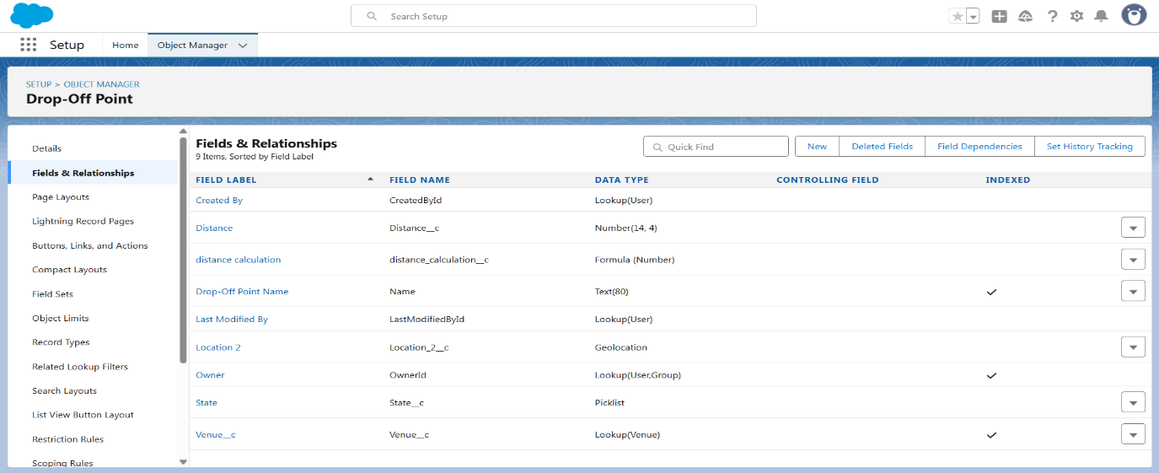

Fig 2 : Drop off Point Custom objects

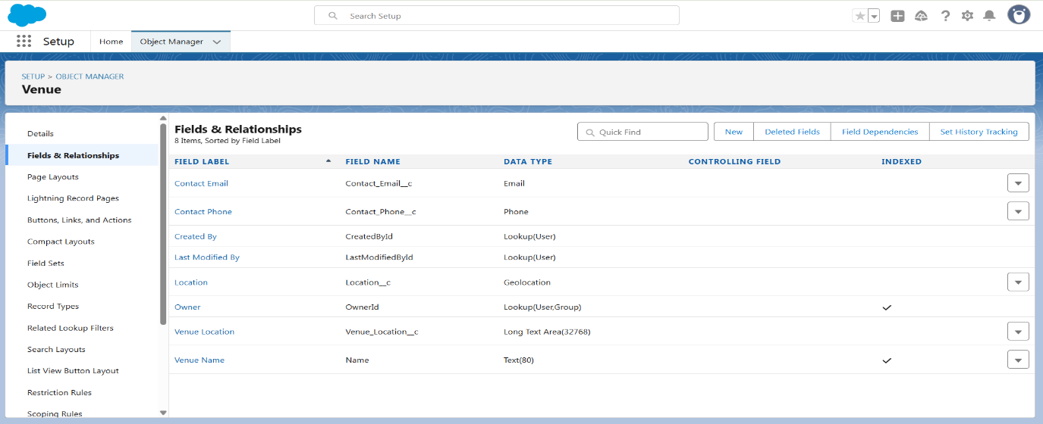

**Fig 3 : Venue Custom objects**

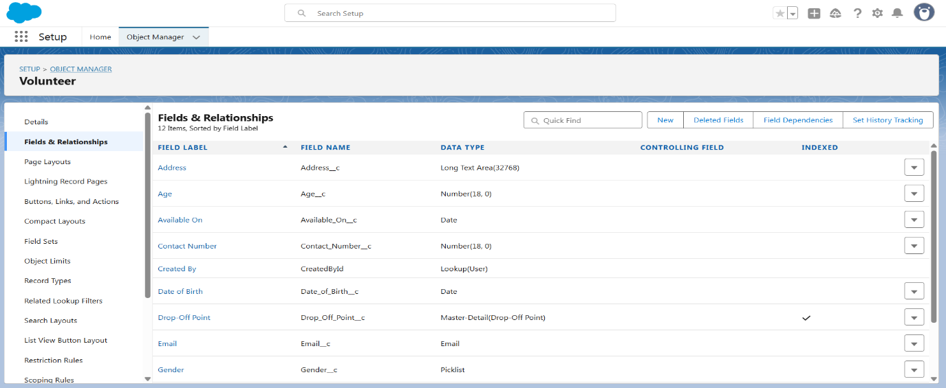

**Fig 4: Volunteer Custom objects**

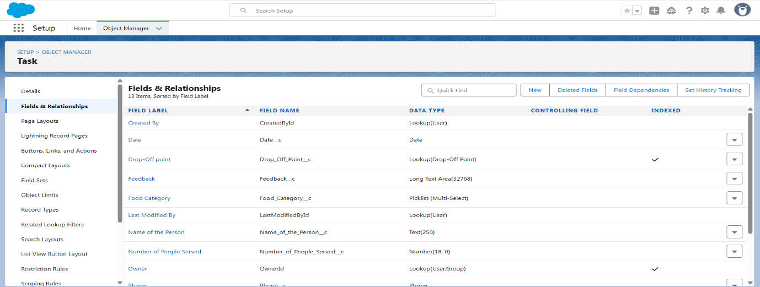**Fig 5 : Task Custom objects**

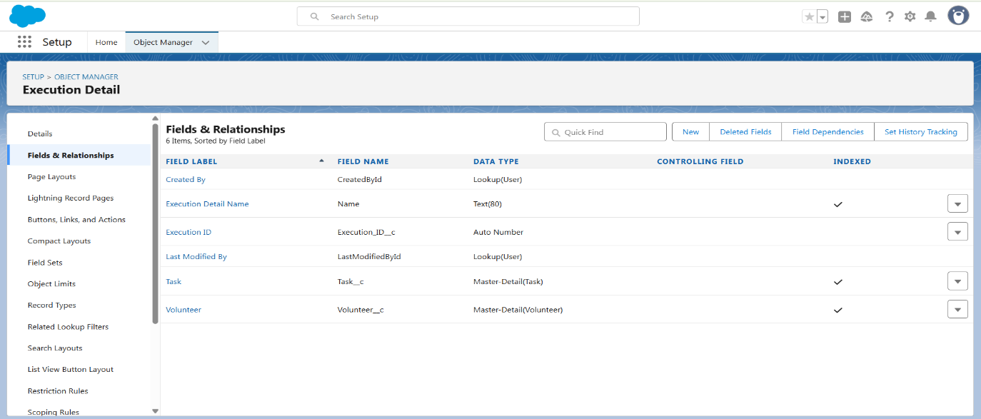

**Fig 6 : Execution Detail Custom objects**

**Phase 2: Salesforce Development – Backend & Configurations**

In this phase, the team concentrated on implementing the core features of the FoodConnect application using Salesforce’s backend capabilities and configuration tools. Based on the plan established in Phase 1, the process began by setting up a Salesforce Developer Org and preparing the environment to build custom objects, automation workflows, and validation rules that would support smooth food donation and delivery operations.

Custom objects such as *Venue*, *Drop-Off Point*, *Volunteer*, *Task*, and *Execution Detail* were created with appropriate fields and relationships. To maintain data quality, validation rules were added—for example, ensuring donation expiry dates occur in the future, food quantities are positive, and mandatory fields are completed. These measures safeguarded data integrity at every step.

Automation played a critical role in this stage. Salesforce Flows were configured to automatically create task records and assign volunteers based on donation location. Process Builder and Approval Processes streamlined notifications and approval steps, while Apex triggers were developed for more advanced logic, such as calculating and storing distances between venues and drop-off points to support sharing rules.

Security and performance were also prioritized. Field history tracking was enabled for key fields like *Task Status* and *Volunteer Assignment*. Lookup and Master-Detail relationships were used to ensure data consistency and proper record linking.

By the end of this backend development phase, the system was fully functional, automated, and secure—ready to integrate with the user interface in the following stage.

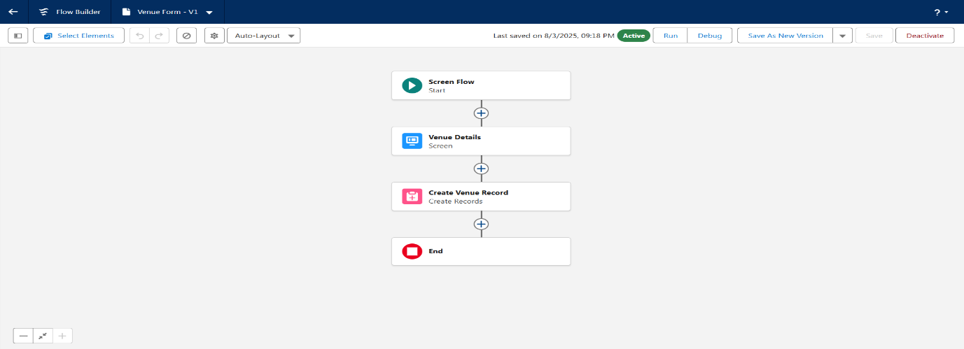

**Fig 7 : Screen Flow**

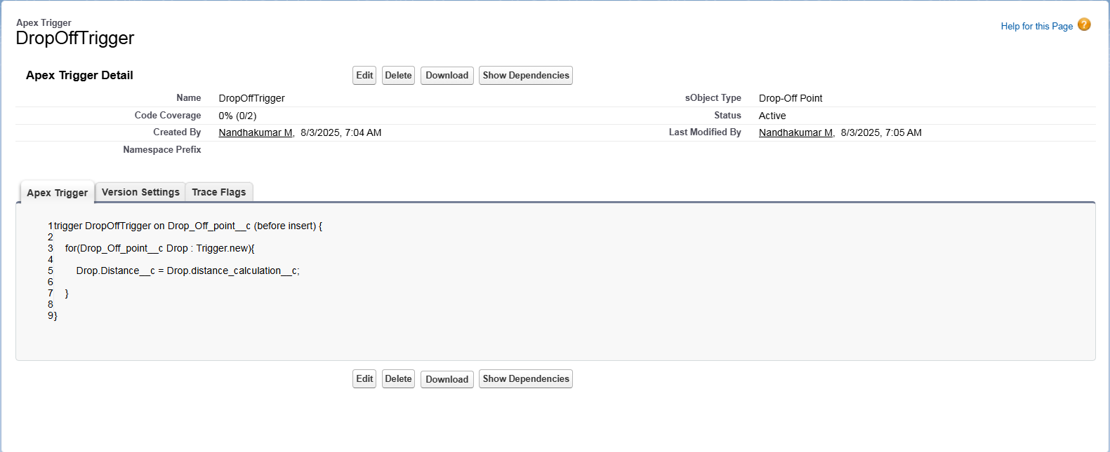

**Fig 8 : Apex Trigger**

**Phase 3: UI/UX Development & Customization**

In this phase, the focus was on creating a user-friendly and efficient interface for all user types—donors, NGOs, volunteers, and administrators. Using Salesforce Lightning tools, the team designed customized layouts and intuitive navigation, ensuring that users could interact with the system effortlessly and complete their tasks without confusion.

A dedicated **Lightning App** named *FoodConnect* was built using App Manager, serving as a central hub for accessing all relevant tabs and records. Custom tabs were created for key objects such as *Venue*, *Drop-Off Point*, *Volunteer*, *Task*, and *Execution Detail*, allowing users to view and manage records in a well-structured manner.

Page Layouts were customized according to user roles, ensuring that each user only saw the fields and sections relevant to their responsibilities. **Dynamic Forms** were implemented to control field visibility based on record data, reducing clutter and enhancing clarity. **Lightning Record Pages** were configured through Lightning App Builder to arrange components like related lists, report charts, and flow screens.

To further enhance the user experience, embedded reports and dashboards provided real-time visual insights into donation status, volunteer performance, and distribution coverage. A Flow-based form was introduced to simplify venue creation, and optional **Lightning Web Components (LWC)** were explored to add modern, responsive UI features.

By the end of this phase, FoodConnect’s interface was not only functional but also visually clear, intuitive, and tailored to the needs of its diverse user base.



**Fig 9 : App Builder**

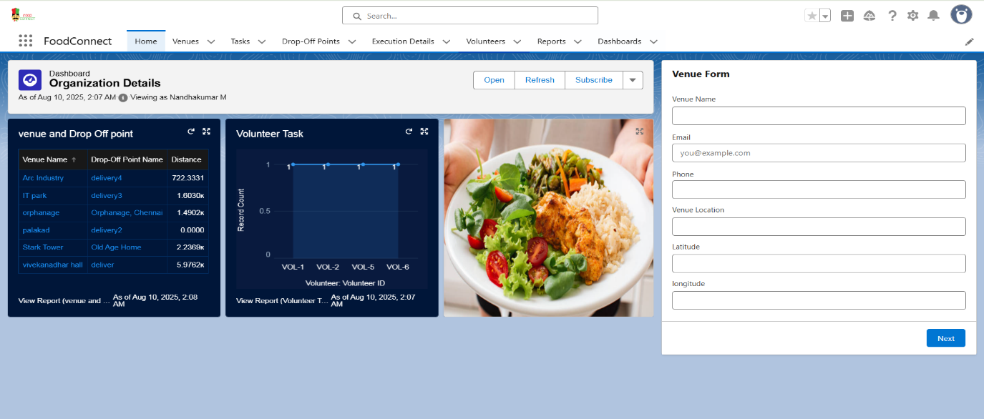

**Fig 10 : App Page**

**Phase 4: Data Migration, Testing & Security**

This phase centered on importing initial data, thoroughly testing application features, and establishing strong security measures to ensure controlled access for all user roles. Careful planning and execution were critical to guarantee that FoodConnect would operate smoothly in real-world conditions while preserving data integrity and delivering a seamless user experience.

**Data migration** involved loading records such as donors, NGOs, volunteers, and food donation entries into the custom objects. For smaller datasets—like NGO and donor details—the **Data Import Wizard** was used for quick uploads. For larger datasets, such as bulk donation records or tasks, the **Data Loader** tool ensured faster and more accurate imports. Predefined data templates aligned with object field structures, reducing the risk of mapping errors during migration.

**Testing** was performed both manually and programmatically. Manual test cases verified critical processes, including venue creation, task assignment, volunteer lookup, and delivery completion. In parallel, **Apex test classes** were developed to validate custom triggers and logic, achieving over 75% code coverage. Automation flows and processes were tested with different input scenarios to ensure that volunteer assignments, record updates, and notifications functioned correctly.

By the end of this phase, the system had been populated with accurate initial data, validated through rigorous testing, and secured with role-specific access controls—setting the stage for deployment.

**Security configurations** were a key focus during this phase to safeguard sensitive data and enforce role-based access controls. A **Role Hierarchy** was implemented, granting full access to Administrators while restricting NGOs and Volunteers to limited, role-specific views. **Profiles** and **Permission Sets** were tailored to match the responsibilities of each user group, ensuring they could only interact with relevant records.

**Sharing Rules** were applied using distance-based criteria so that users could only access records within their operational geographic areas. Additional security and data quality measures included enabling **field history tracking**, implementing **duplicate rules**, and setting up **matching rules** to maintain accuracy and auditability.

By the conclusion of this phase, the system was **stable, secure, and deployment-ready**—with all features thoroughly tested, data correctly structured and imported, and precise access controls ensuring the right users had the right level of access.

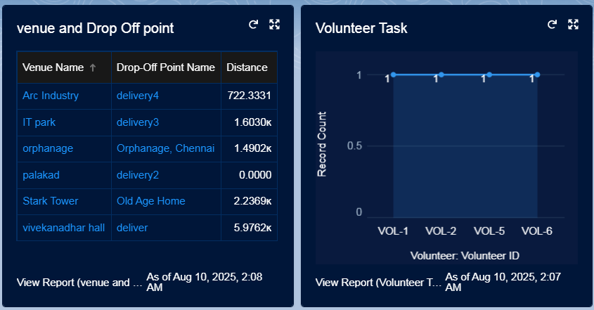

**Fig 12 : Data**

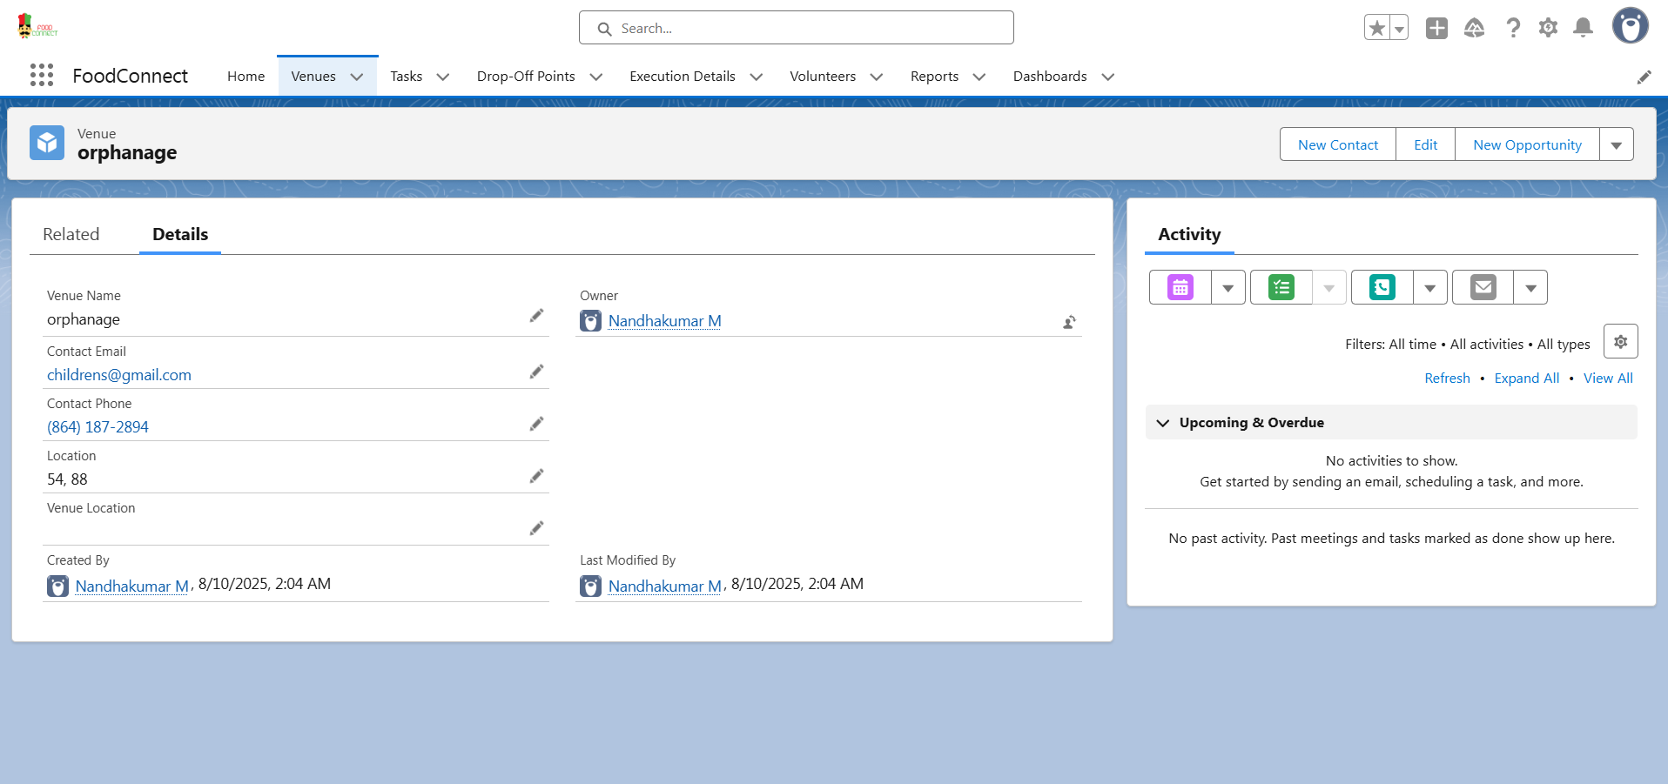

**Fig 11 : Testing**

**Phase 5: Deployment, Documentation & Maintenance**

The final phase of the FoodConnect project focused on deploying the application to the production environment, preparing comprehensive documentation, and establishing a plan for ongoing maintenance. This stage ensured the system was fully ready for real-world use and equipped for continuous support and enhancement.

**Deployment** was carried out using Salesforce **Change Sets** to transfer metadata components—such as custom objects, fields, flows, validation rules, and dashboards—from the development environment to production. Every change was reviewed and tested before deployment to minimize errors. Post-deployment activities included activating flows, updating permissions, and verifying profile settings to ensure smooth operation in the live environment.

**Documentation** was created to guide both end-users and administrators. It detailed the system’s structure, data model, relationships, automation workflows, test cases, and user roles. Visual aids, including screenshots of UI layouts, reports, dashboards, and flow diagrams, were included to make the content easy to follow. This documentation serves as a valuable reference for future developers, testers, and administrators.

**Maintenance** plans were put in place to keep the system efficient and reliable. Administrators will routinely monitor dashboards, review flow and trigger executions, and check for failed automations. **Debug logs** and **error notifications** will help quickly identify and resolve issues. User feedback will be gathered regularly to guide future enhancements, ensuring the system continues to evolve and meet the needs of its stakeholders.

**Conclusion**

The FoodConnect project successfully utilized the Salesforce platform to create an intelligent, automated, and user-friendly solution for managing surplus food distribution. By uniting donors, NGOs, and volunteers within a single centralized system, it made the food donation process more organized, efficient, and transparent.

Key functionalities—such as automated volunteer assignments, real-time status tracking, and role-based access—significantly reduced manual effort and enhanced coordination among all stakeholders. Reports and dashboards delivered actionable insights, enabling better monitoring and informed decision-making.

This CRM solution not only minimized food waste but also ensured that surplus food reached the right beneficiaries at the right time. It promoted transparency, accountability, and greater social impact through effective resource utilization.

Ultimately, FoodConnect demonstrated how digital solutions like Salesforce can address real-world challenges and contribute to community welfare by streamlining critical processes such as food donation and delivery.

**Future Enhancements**

While the current version of FoodConnect fulfills the essential requirements for managing food donations, several enhancements can make it more user-friendly, scalable, and efficient in the future:

1. **Chatbot for Donation Tracking**  
   Integrating a chatbot into the platform would allow donors and NGOs to track donations in real-time through a simple chat interface. This feature would enhance the user experience by eliminating the need to navigate multiple pages.
2. **AI-Based Volunteer Route Optimization**  
   Leveraging artificial intelligence, the system could recommend the most efficient delivery routes for volunteers based on location, traffic patterns, and delivery priorities. This would help save time, reduce fuel costs, and improve delivery punctuality.
3. **Mobile App Support using Salesforce Mobile SDK**  
   Developing a mobile version of FoodConnect using the Salesforce Mobile SDK would provide better accessibility, particularly for volunteers. Through the app, users could view assigned tasks, update delivery statuses, and receive instant notifications directly on their smartphones.

These proposed enhancements aim to extend the system’s capabilities, making FoodConnect smarter, more interactive, and more convenient for all stakeholders.